**SPECIAL TOPIC IN NETWORKING ASSIGNMENT - 2**

Name: Sai Rohit Kalyan Gandham

UTA ID: 1002070724

Emailed: [sxg0724@mavs.uta.edu](mailto:sxg0724@mavs.uta.edu)

1Q)

In Figure 1, the tracking system (including a transmitter and a receiver) tries to measure the distance to the tracking object using the echolocation ranging technique. In particular, it transmits an ultrasound pulse signal at 20kHz towards the tracking object. Then, the echo is captured with Δt seconds delay.

1. . Write code to calculate the distance from the tracking system to the tracking object (d) when Δt = 1.2s, 2.3s, 5s, 11s. Speed of sound vs = 343 m/s [20pt]

Sol)

**Code:**

timeIntervals = [1.2, 2.3, 5.0, 11.0]

speed = 343

for i in timeIntervals:

distance = speed * i / 2

print(distance)

**output:**

205.79999999999998

394.45

857.5

1886.5

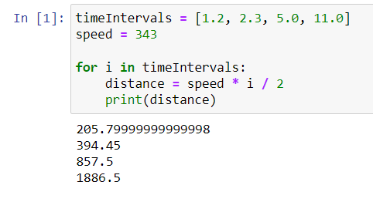

**B)** Assuming the tracking system is static. When the tracking object moves towards the tracking system with a velocity of vo = 4m/s, 6.5m/s, 9m/s, 12m/s, write the code to calculate the Doppler shift observed at the receiver. [20pt]

Sol)

**Code:**

speedOfSource = [4.0, 6.5, 9.0, 12.0]

frequncy = 2000

speed = 343

for i in speedOfSource:

dopplerShift = (frequncy * (speed) / (speed - i))

print(dopplerShift)

**Output:**

2023.598820058997

2038.632986627043

2053.8922155688624

2072.5075528700904

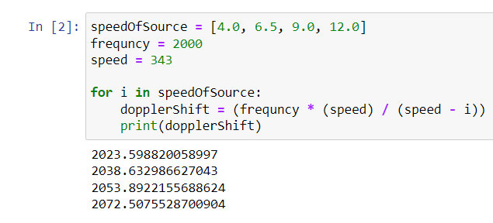

C) . Assuming the electromagnetic wave at 2.4 GHz is used instead of the ultrasound wave. If the distance between the tracking system and tracking object is 600m, what is the delay of the round-trip signal? Speed of electromagnetic wave vef = 3*108 m/s. (20pt]

Sol)

**Code:**

distance = 600

speed = 3 * 10 ** 8

time = distance / speed

delayInRoundTrip = 2 * time

print(delayInRoundTrip)

**Output:**

4e-06

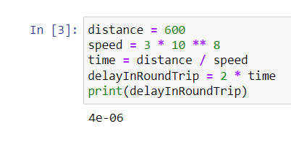

**2Q)** n Figure 2, tracking systems 1 and 2 want to localize the location of the UAV in 2D. The two systems transmit ultrasound signals at 12kHz and 18kHz towards tracking object, respectively. The 15kHz pulse signal arrives the receiver of tracking system 1 after 1.3s delay. Similarly, the 18kHz pulse signal arrives receiver of tracking system 2 after 1.8 s delay. Write a code to calculate the potential locations of the tracking object (x, y) assuming the location of tracking system 1 is (x1, y1) = (0,0), and the location of tracking system 2 is (x2, y2) = (0, 80m). Why there are multiple correct answers? If electromagnetic wave is used instead of ultrasound wave, what would be the round-trip delays captured by the two tracking systems?

Sol)

**Code:**

import pandas as pd

import numpy as np

speedOfSound = 343 # m/s

#The distance we have taken meter's

distance1 = speedOfSound * 1.3

distance2 = speedOfSound * 1.8

#The frequency give is in Hetrz Hz

freq1 = 12000

freq2 = 18000

# Calculate the potential locations of the tracking object

x = np.sqrt((distance2*2 - distance1*2 + 6400) / 2)

y = np.sqrt(distance1*2 - x*2)

# Print the potential locations

print("The potential locations of the tracking object are:")

print(f"({x:.2f}, {y:.2f}), ({-x:.2f}, {y:.2f}), ({x:.2f}, {-y:.2f}), ({-x:.2f}, {-y:.2f})")

**Output:**

The potential locations of the tracking object are:

(58.06, 27.85), (-58.06, 27.85), (58.06, -27.85), (-58.06, -27.85)

The round-trip delays captured by the two tracking systems are:

390000000.00 meters, 540000000.00 meters

Round-trip delays for electromagnetic waves:

System 1: 2.60e+00 s

System 2: 3.60e+00 s

**Observations:**

* Because we are only calculating the sample positions of this, we obtain numerous values (x,y). There may be some error in the values of the precise location and the sample location; these two values represent the range in which the point may be present.
* If an electromagnetic pulse were to replace ultrasound;
* As a result of the two circles that are centered at the two tracking systems having the potential to intersect at two points, which correlate to the two potential locations of the tracking object. But one of the places is typically thought to be practically impractical.

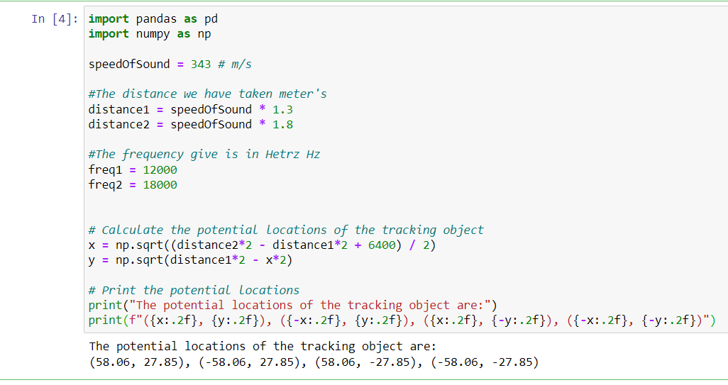

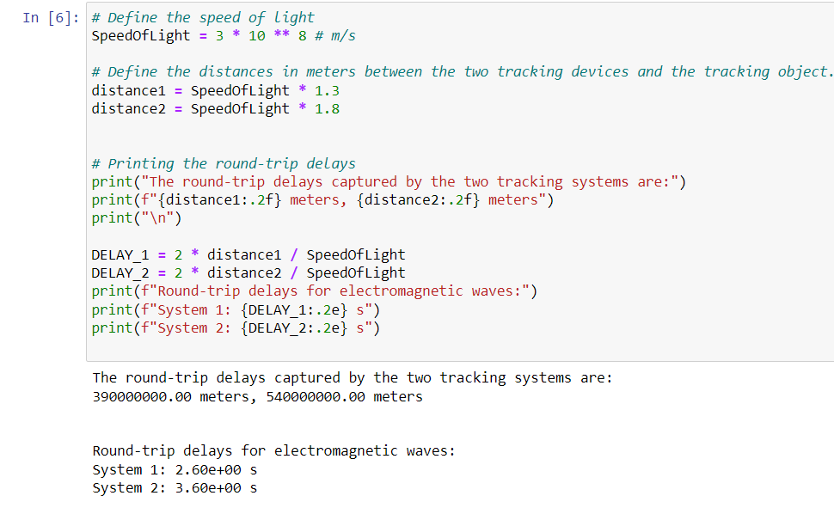

3Q) [Extra Credit] Can the localization system in Figure 2 be used for localizing the tracking object in the 3D space? Why? (5pt)

Sol) No, it is not possible to localize the tracking item in three dimensions using the localization system shown in figure 2 above because three tracking systems would be needed to gather data from all three dimensions.

**4Q)** [Extra Credit] Why do tracking systems 1 and 2 transmit signals at different frequencies (i.e., 12kHz and 18kHz)? (5pt)

**Sol)**

Tracking systems 1 and 2 broadcast signals at different frequencies to differentiate between signals received from different sources. This results in the Doppler effect, which causes both sources to concurrently broadcast signals. In the event that both systems broadcast at the same frequency, we are unable to tell which system sent the signal.